Ensemble Learning in Diagnosing Breast Cancer

Bill Tang (bt294)| Lini Tan (lt398)

Cornell University

Author Note

Bill Tang, School of Engineering, Cornell University.

Lini Tan, School of Art and Science, Cornell University

Correspondence concerning this article should be addressed to Bill Tang and Lini Tan of Cornell university.

Contact information:

Bill Tang: [bt294@cornell.edu](mailto:bt294@cornell.edu)

LIni Tan: [lt398@cornell.edu](mailto:lt398@cornell.edu)

Abstract

The study of applying ensemble learning in diagnosis of breast cancer probes usage of many fundamental machine learning techniques that are widely used in both industry and academia nowadays. Techniques include Decision Tree, Random forest, KNN, Naïve Bayes, Logistic Regression, Neural Network. The idea is to train various techniques with same training data set, then to test the results on the rest of the data set, and eventually to measure the goodness of fit between the real data and the expected data by looking at the cross-validation scores.

The main computer languages used in this study include Python, JavaScript, JQuery.

Introduction

The emergence of our thought on diagnosing breast cancer with machine learning method comes from Professor Bart, who taught Artificial intelligence at Cornell University. In 2017 fall, lecture slide 13, he mentioned how Decision Tree surpassed human experts and has been successfully diagnosing breast cancer. Out of curiosity, we wondered two questions: Why Decision Tree not other machine learning models is used? Is there a better machine learning technique that results the better prediction?

Following curiosity about this two questions, we conducted this case study. In this report, we will first briefly introduce each method we used. Then, we demonstrate the test methods followed by test results. In the end, we will compare the results from different method, and make a conclusion based on the results.

Introduction on Testing Methods

1. Decision Tree

Decision Tree, a form of supervised learning, is widely used to support making decisions by generating a tree-like graph.

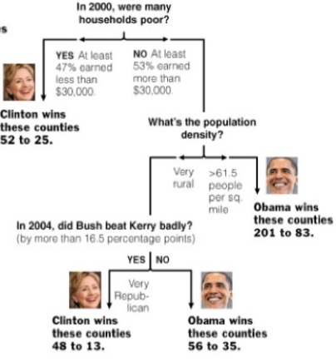

Figure 1.1 Decision Tree.

This simple example regarding 2008 U.S. President election is decision tree is one of many quintessential cases of application of decision tree.

The decision tree is very natural to human. A decision is made by walking down the tree from the root. At each level, a decision node specifies a choice of some attribute with two or more alternatives. Every decision node is part of a path to a leaf node which indicates the classification of a data set.

To construct a Decision Tree consistent with the training example, Decision Tree learning algorithm is used. The idea is to recursively choose the most significant attribute as root, and then use a top-down greedy search through the space of possible Decision Tree. The significance of the attribute is determined by something called “Information Gain” which is calculated by using the concept of “Information Entropy”.

1. Random Forest

Similar to decision tree, a Random Forest algorithm is a supervised classification algorithm working as a large collection of decorrelated decision trees. Instead of only one tree as with Decision Tree, many Decision Trees are used in Random Forest Algorithm. Also, instead of using information gain and gini index for calculating the root node, finding the root node and splitting the feature nodes will be randomized.

To construct a Random Forest from a sample, the concept of bagging is used. The bagging is to average noisy and unbiased models in order to create a model with low variance. The basic idea is to divide the sample into M subsets, and then create M decision trees with the corresponding data using Random Forest Algorithm.

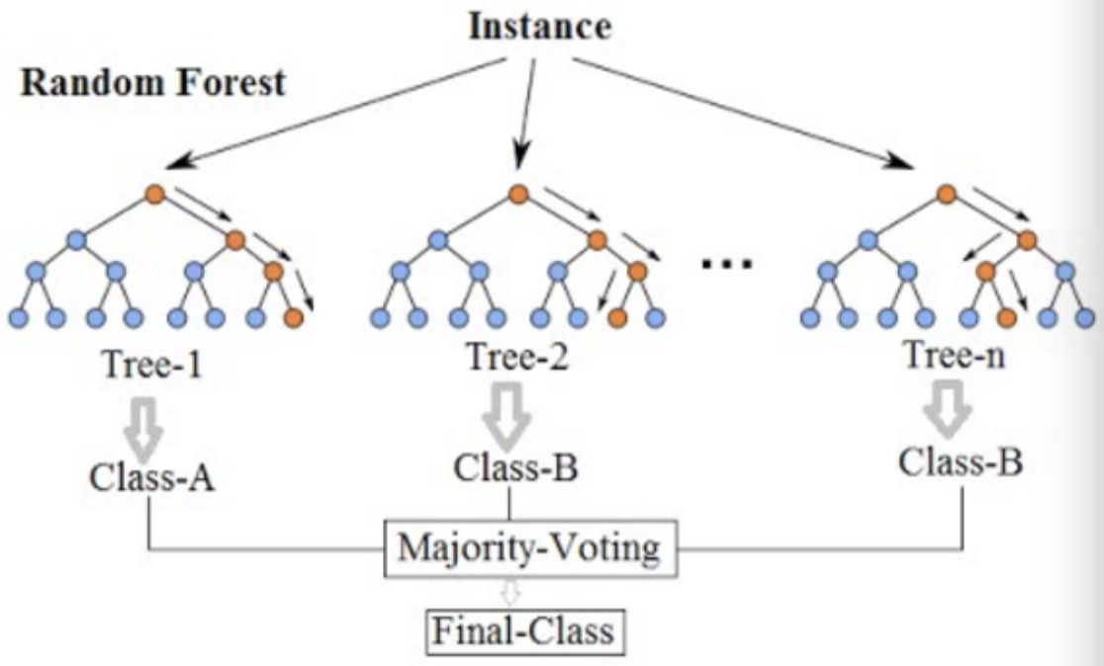

Figure 1.2 Random Forest

There exist three decision trees in this random forest. Three classifications will be obtained from three trees to go into the final voting. The prediction is “class B” in this case.

To make a decision using Random Forest, an instance is feed into the root of each sub-decision tree. Sub-trees will then produce classifications from each one of them. The final prediction is based on majority voting among the classifications of Decision Trees.

1. K-nearest Neighbor algorithm

The k-nearest neighbors algorithm is a supervised learning, non-parametric method used for classification. The idea of clustering is used to group a set of objects in a way that objects in the same group are more similar to each other than those in other groups.

In k-NN algorithm, the classification of a new data point is based on the “distance metric” to k nearest neighbors in the training data set. Then, this new object is classified by a majority vote of its neighbors.

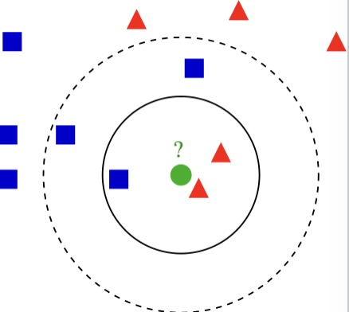

Figure 1.3 k-NN algorithm

The new test object is colored in green.

If k=3 (solid line circle), the new object is assigned to the red triangle class since there are two triangles and only one square in the circle.

If k = 5 (dashed line circle), the new test object should be assigned to blue square class because there are three squares, but only two triangles.

Correctly choosing the k factor determines the total accuracy of such algorithm. To gain optimal value of k, we can segregate the training set and validation set from the initial data set. Then, plot the validation error curve to obtain the optimal value of k at the minimal error point.

1. Naïve Bayes Method

In machine learning, Naïve Bayes method forms a group of simple probabilistic classifiers by applying Bayes’ theorem with strong independence assumptions between the features.

Given a small set of training data, Naïve Bayes classifiers can be trained very efficiently in a supervised learning setting. To estimate the parameters for naïve Bayes models, the idea of maximum likelihood is used, meaning one can work with the naïve Bayes model without accepting Bayesian probability or applying Bayesian methods.

1. Logistic Regression

Logistic regression was developed by David Cox, which is used to estimate the probability of a binary response based on one or more predictor variables. In the regression model, the dependent variable is categorical. It allows one today that the presence of a risk factor increases the odds of a given outcome by a specific factor.

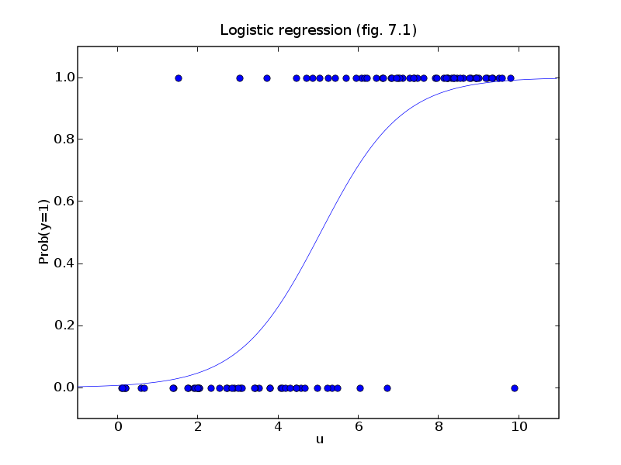

Figure 1.4 Logistic Regression

Like the figure on the left, logistic regression is used to describe data and to explain the relationship between one dependent binary variable and one or more nominal, ordinal, interval or ratio-level independent variables.

The logistic regression is simple to implement and easy to compute. However, the decision boundary has to be linear (i.e. separable by a hyperplane). It could also end up being a feature selection problem as well. This is the problem we need to consider when using logistic regression.

1. Neural Network

Artificial neural networks (ANNs) or [connectionist](https://en.wikipedia.org/wiki/Connectionism) systems are computing systems inspired by the [biological neural networks](https://en.wikipedia.org/wiki/Biological_neural_network) that constitute animal brains. Such systems learn (progressively improve performance on) tasks by considering examples, generally without task-specific programming.

To construct a neural network, we consider it as a collection of connected units called artificial neurons. Each connection between neurons can transmit a signal from one to another. The receiving neuron can process the signals and then signal neurons connected to it.



Figure 1.5 Neural Network

Here, the red nodes are input, the blue nodes are hidden layer and output are green nodes. Each circular node represents an artificial neuron and an arrow represents a connection from the output of one neuron to the input of another.

In order to learn multi-layer neural nets, we consider the backpropagation algorithm for training such networks.

Testing Approaches and Results

**Data Searching Stage**

To answer two questions mentioned in the introduction of this report, we first searched raw data on Machine Learning Repository. We obtained the Mammographic Mass Data Set which is published by Image Processing and Medical Engineering from Fraunhofer Institute for Integrated Circuits in Germany.

As one of the most effective method for breast cancer screening today, Mammography, on the other side however, has low positive predictive value of breast biopsy. The reason for this is the approximately 70% unnecessary breast biopsies. Many computer-aid diagnosis (CAD) systems had been developed to decrease the such high rate. Data gathered by professionals can be used to train the systems, and to compare the performance of CAD systems to that of radiologists.

This data set contains 961 data entries, and each tuple has six attributes. They are:

1. BI-RADS assessment (from 1 to 5): an assessment of how confident the severity classifications. This is a subjective attribute assigned by human, but not a predictive feature used to train the system. Thus, we discarded this attribute.

2. Age: patient's age in years (integer)

3. Shape: mass shape: round=1, oval=2, lobular=3, irregular=4

4. Margin: mass margin: circumscribed=1, microlobulated=2, obscured=3, ill-defined=4, spiculated=5

5. Density: mass density high=1, iso=2, low=3, fat-containing=4

6. Severity (benign=0 or malignant=1):

Our goal is to apply six machine learning models to this data, and measure the success of

results based on the cross-validation value between each trained model and the data set. We want to see if our models can beat the human radiologists’ positive diagnosis which is round 70%, and to conclude which model works the best for the sample data.

**Data Processing Phase**

Before we feed our data into models, we need to process the data first. This includes data I/O, deleting BI-RADS column, taking care of missing data, normalizing the data, and extract the data from table frame in Panda into two Numpy arrays with just numerical data. Afterwards, the data can be used by scikit_learn to feed into various models to be trained.

**Testing Phase**

1. Decision Tree
2. Random forest
3. KNN
4. Naïve Bayes
5. Logistic Regression
6. Neural Network

Conclusion

After a thorough test on six wildly known machine learning techniques, we noticed that…

Reference:

AI lecture 13 p63 “how well does it work?”

<http://dataaspirant.com/2017/05/22/random-forest-algorithm-machine-learing/>

<https://community.tibco.com/wiki/random-forest-template-tibco-spotfirer-wiki-page>

<https://en.wikipedia.org/wiki/K-nearest_neighbors_algorithm>

<https://www.analyticsvidhya.com/blog/2014/10/introduction-k-neighbours-algorithm-clustering/>

<https://en.wikipedia.org/wiki/Naive_Bayes_classifier>

<https://archive.ics.uci.edu/ml/datasets/Mammographic+Mass>